Diabetes Dataset

We are aiming to use this dataset in the project to predict diabetes in patients based on various diagnostic measurements using linear regression for classification and logistic regression ,neural networks as classifiers.

Data set Name: Diabetes
URL: https://www.kaggle.com/datasets/mathchi/diabetes-data-set
Rows:769 columns:9

Intended uses : Our dataset contains key details on pregnancies, glucose levels, blood pressure, skin thickness, insulin levels, body mass index, diabetes pedigree function, and age, along with an outcome variable that shows whether or not diabetes is present. This information helps us identify patterns and better understand the factors linked to diabetes.

For instance, a patient with high levels of glucose, blood pressure, skin thickness, and insulin is more likely to develop diabetes. Conversely, low or zero values mean that probability of developing diabetes is very low, or the condition is non-diabetic.

Details of attributes:
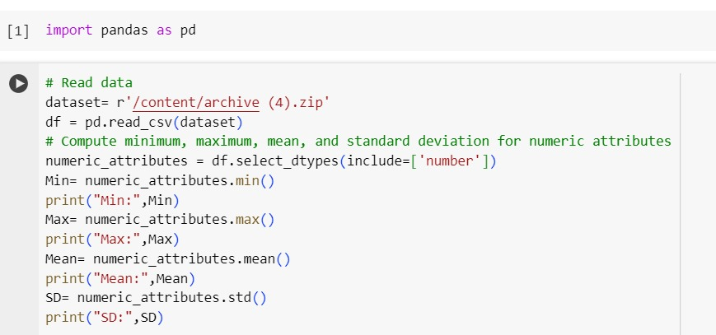
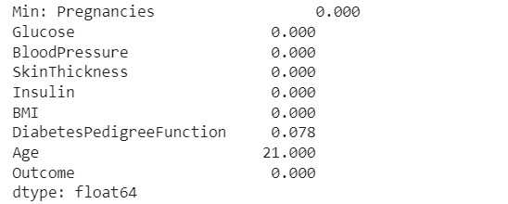
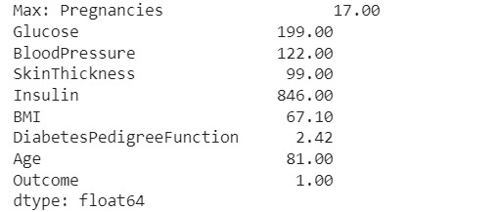
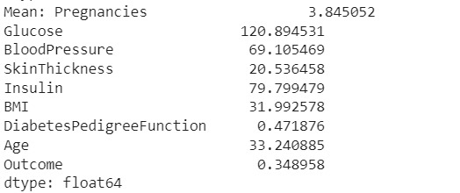
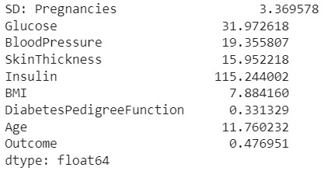

Histogram:
